Team 4:  Carolina Carrillo, Sofia Cavallo, Gregory Lang, Mohammad Rao

Chosen Topic/Rationale: Gun Violence in the US

For our project we decided to do a combination of web scraping and Leaflet to show the locations of gun violence incidents from 2014 to 2019. The data source we decided to use is GVA (Gun Violence Archive), which documents incidents of gun violence and gun crime nationally.

Some questions we are interested in answering:

* Where in the US is the highest concentration of gun violence?
* How does gun violence vary by US state?
* Are there more injuries or deaths from gun-related violence?
* How has gun violence increased or declined over the selected timeframe?

Link to Data/Screenshots:

<https://www.gunviolencearchive.org/reports/mass-shooting?year=2019>

<https://www.gunviolencearchive.org/reports/mass-shooting?year=2018>

<https://www.gunviolencearchive.org/reports/mass-shooting?year=2017>

<https://www.gunviolencearchive.org/reports/mass-shooting?year=2016>

<https://www.gunviolencearchive.org/reports/mass-shooting?year=2015>

<https://www.gunviolencearchive.org/reports/mass-shooting?year=2014>

<https://www.gunviolencearchive.org/reports/mass-shooting?year=2013>

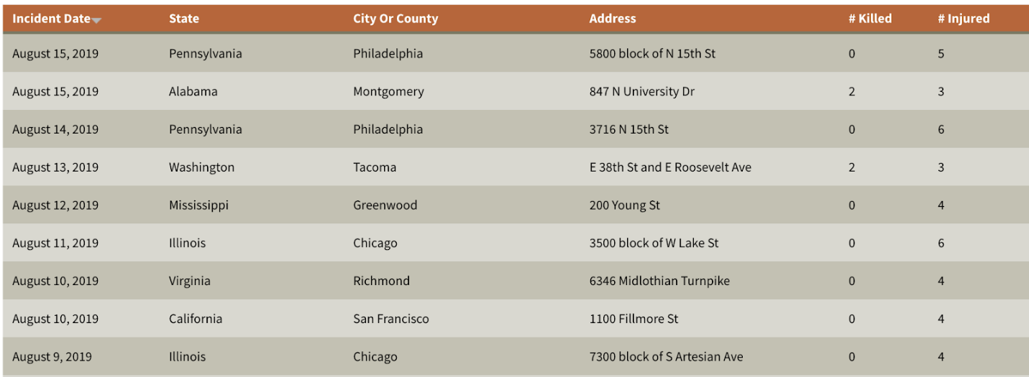

Visualization Examples:

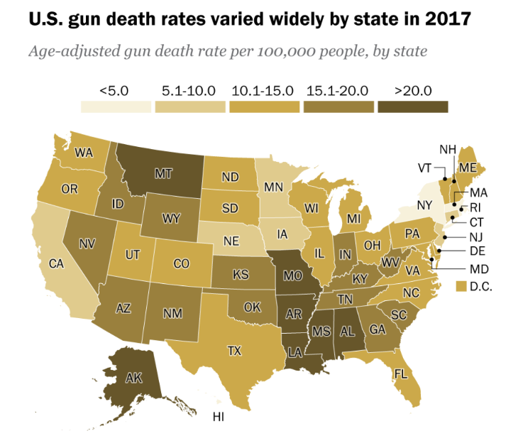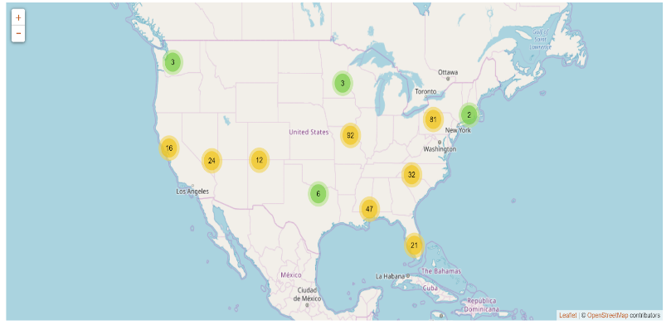

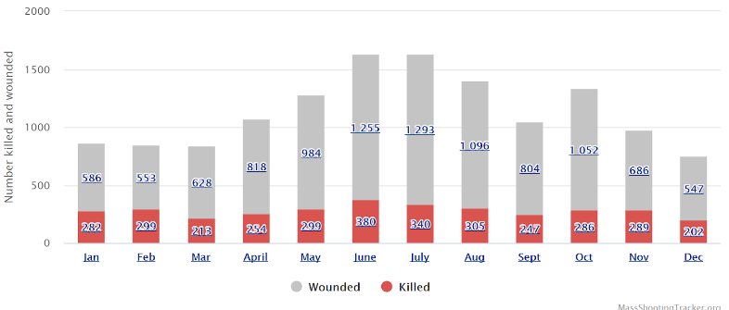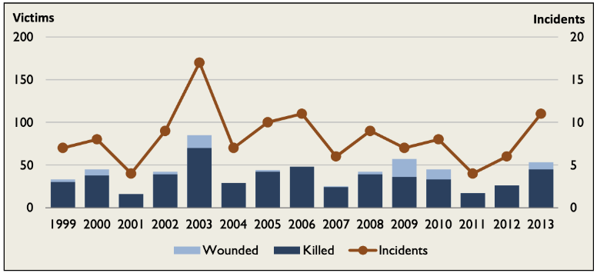

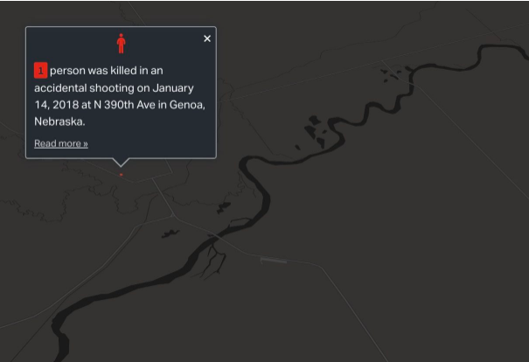

Data Collection:

1. Use beautifulsoup to mine the GVA website for csv files containing data from 2014-2019. Also mine to extract incident data (geolocation, and the involved participant type, status, and age) on each entry point.
2. Extract data in pandas, transform data to create a master dataframe for the entire period
3. Save as CSV file. Also load into SQLite to be used with a Flask-powered API server that will host the site.
4. Use Leaflet.js to map the locations of the shootings. Also nested bar graphs?
5. Create at least three views that allow for user-input to select either date range, fatalities vs non-fatal incidents, and location on interactive map or date range, fatalities vs non-fatal incidents, participant type, status, or age on interactive bar graphs.

GitHub Repository Link:

<https://github.com/sofiacavallo/project2_team4.git>